Compact mobile robot AMY from DS Automotion with smart load transfer:
Efficiency through agility

With AMY, DS Automotion is launching an extremely compact and maneuverable autonomous mobile robot (AMR) for transporting loads of up to 25 kg. The smallest vehicle in the fleet of the established manufacturer from Linz offers full flexibility with predictable autonomy and can be easily integrated into larger fleets. Its load handling, which is as revolutionary as it is simple, enables the creation of cost-effective and low-maintenance intralogistics solutions, especially for handling small parts.

Efficiency booster for small parts handling

Specially designed to be used in industrial production and intralogistics processes, AMY is designed for the driverless transportation of small loads weighing up to 25 kg. AMY can transport these in the form of standardized small load carriers or in several smaller containers from or to manual workstations and exchange them automatically with conveyor systems or passive transfer stations available from DS Automotion as a supplement via a dynamic load handling device.

Fast, flexible and secure

DS Automotion's smallest vehicle in the field of mobile robotics impresses with its very simple operation and high flexibility. The modular on-board electronics developed in-house and smart control software enable rapid operation using the plug & play method, both individually and in a swarm. This means that AMY can take over transport operations immediately.

Thanks to its differential drive, AMY can turn on the stand and drive at speeds of up to 1.8 m/s in both directions using laser scanners at the front and rear with 360° all-round visibility. The AMR navigates exclusively contour-based. Two TOF cameras prevent collisions with overhead objects such as table tops.

Plannable autonomy and simple integration

Plannable autonomy gives AMY a new level of efficiency. The AMR can either drive completely autonomously or follow virtual lane guidance and, if desired by the operator, avoid unexpected obstacles. In addition, like all current DS Automotion vehicles, AMY is equipped with the VDA 5050 interface and can process files with the Layout Interchange Format (LIF). This means that AMY can be operated under any fleet management system, and under the NAVIOS fleet manager from DS Automotion also in mixed operation with any other vehicles from this leading manufacturer. This makes AMY particularly suitable as a cost-effective addition to existing systems.

Bilder:

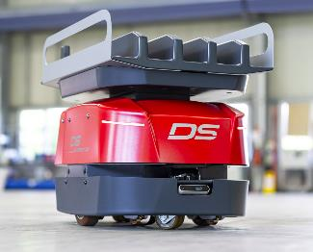 | AMY is the latest and smallest addition to DS Automotion's AMR fleet and is designed for the driverless transportation of small loads weighing up to 25 kg.  All pictures: DS Automotion
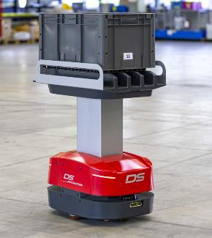 | Thanks to its revolutionary, simple load handling, AMY is versatile and can be used for transporting small materials in standardized small load carriers or in several smaller containers.
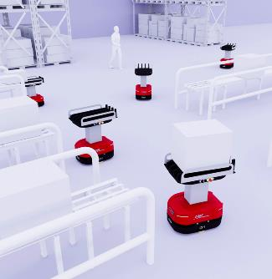 | Contour-based navigation with plannable autonomy and the VDA 5050 interface enable optimal use alone, in a swarm or under any fleet management system, even in mixed operation with other vehicles.
Technical data - Quick Facts
Transport weight max. 25 kg
Speed max. 1.8 m/s
Navigation contour-based
Power supply Automatic charging via charging contacts
Dimensions (l x w x h) 638 x 428 x 349 mm
Special features VDA 5050 interface, swarm intelligence, LIF file compatible,
plannable autonomy

About DS Automotion

DS Automotion is a global leader in mobile robotics for in-plant logistics and assembly applications. With over 40 years of experience, the company develops mobile robots and fleet management systems such as AGVs and AMRs. The company's core competencies are continuously developed with a focus on state-of-the-art software solutions. Headquartered in Linz, Austria, with subsidiaries in Germany, France and the USA, the company employs over 300 people and is part of the SSI Schaefer Group.

Further information can be found at www.ds-automotion.com.

